**Overview of GHHIN Stocktaking Papers**

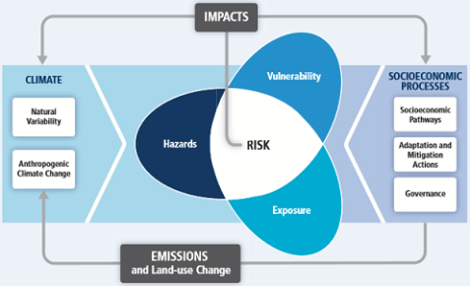A one-time and complementary technical paper will be prepared during June-July 2017 to inform the common framework of issues and activities that GHHIN will focus on and track through its web-platform, forums, and synthesis report. They will inform the likely content for the global synthesis report; serve to collect baseline content information; and help expand upon previous guidance documents and identify alignment with the NOAA National Integrated Heat Health Information System.

The reports have been organized around the principles of the IPCC climate risk framework. They will take stock of the relevant categories of heat-health knowledge and information which are required to inform decisions and actions across timescales to reduce risks across the dimensions of hazard, vulnerability, exposure, risk reduction, and monitoring impacts. We hope to emphasize the circular nature of science/information feeding into responses, and back to informing science/information needs.

**Expected Outcomes of Stocktaking Papers**

1. Help organize and inform a common thread framework of domains of information and action to be followed by the GHHIN
2. Provide grounding and content for the development of the global synthesis report, as a one-time effort prior to mechanisms of the platform and forums are established to collect information.
3. Inform core templates for comparative information categories, that can be used as the basis of the country/member profiles.
4. Collect data on existing actions to begin to populate the initial web-based sharing platform and identify key stakeholders, before GHHIN members are asked to contribute.

Chapters on global heat hazards and human exposure across timescales will include Monitoring, Forecasting, and EWS will come under this section – and not responses – and will build on some efforts to compare different HHWS systems, and notably update p 28, table 4 (comparing local and national systems in US, Canada, Germany, Spain, France, UK, China, Hong Kong, Japan, Australia) to include more countries of the WHO/WMO Heatwave and Health Guidance on Warning System Development Guidance Document.

Chapters on human vulnerability to heat and risk reduction actions across timescales will notably update Chapter 6 of the WHO/WMO Heatwave and Health Guidance on Warning System Development Guidance Document.

**Stocktaking of Global Heat Risks and Responses.**

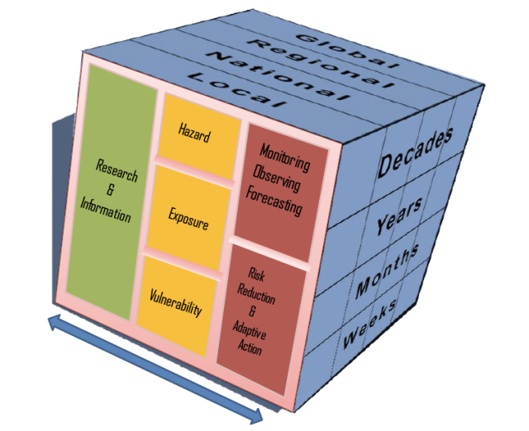**Page target 50, with annexes as required**

This stocktaking report will help identify and outline the global state of the science to understand, predict ambient heat related hazards and exposures to increasing and extreme temperatures.

It will quickly summarize the literature on the state of the hazard; outline and highlight similarities and differences in systems for characterizing the hazards, and temperature prediction across timescales (weather, S2S, and decadal). It will present key considerations used in the literature for measuring human population exposure to extreme and increasing temperatures. It will help identify and outline the global state of understanding human vulnerability to heat exposures, and the broad range of responses and actions which can be taken to reduce human exposures and impacts. It will describe categories of vulnerable populations; highlight similarities and differences in response opportunities and systems, from behavioral to infrastructural, and legal actions which can be taken over different timeframes. Intervention effectiveness will be cited as available.

**Chapter 1: Temperature Hazards**

**1.1: Hazard: Ambient heat hazard characterization**

Describe observed trends of increased warming, of high nighttime temperatures, extreme heat events, of heat hazards in combination with conditions of humidity/air quality.

**1.2: Hazard: Research:** what is the research/method used to inform how an extreme heat event is defined? Inclusion of mortality/morbidity/hospital admission data?)

**1.3: Hazard: global, regional, and national temperature observation and monitoring systems** of (climatological records, RCC capabilities eg: IMD Regional Forecast)

**1.4: Hazard: Extreme Heat Prediction**: State of the science in products, sources of predictability, by timescale: climate predictions, climate outlooks, forecasts, warnings); indices

**1.5: Hazard: Early Warning Systems.** Diverse priorities across timescales: reference table of comparative heat alert systems; parameters, definitions

**Chapter 2: Population Exposures:**

**2.1 Exposures** Discuss definitions and what makes heat dangerous to humans.

Geographic Determinants: Latitude, Urban Heat Islands; Social Determinants (point to vulnerability chapter).

**Chapter 3: Population Vulnerabilities**

This section will outline identified diverse population groups whom are vulnerable to exposure to ambient heat conditions, and represent target populations for protection. It should describe geographic, social, temporal and physiological sensitivities. It should highlight target decision makers who have the ability to take protective actions for these high-risk groups (table). E.g. Workers: Business Owners; Psychotropic pharmaceutical patients: Pharmacists/Physicians; Elderly: Families/Social Services.

**Chapter 4: Responses**

1. **Planning and Governance**: Heat Health Action Plans, legal classification of heat as national emergencies
2. **Institutional Capacity & Partnerships**: Common institutional partners engaged to define and respond to needs. (e.g. who should be/ is involved in forecasting, preparing and responding to the hazard – agreement on lead body)
3. **Engagement and Communication Strategies:** What communication strategies are used and most effective both during an event and for long lead time planning – do communications strategies include targeted outreach to vulnerable populations?
4. **Training and Capacity:** what kinds of training and capacity is needed to better understand and respond to heat health risks
5. **Exposure and vulnerability reducing interventions**
6. Individual
7. Community
8. Work Place
9. Health Facility
10. Policy/Legislative/Regulation
11. Social Services
12. Specified targeted interventions for vulnerable populations

**Chapter 5: Monitoring and Evaluation**

* intervention effectiveness (evaluation products – conference, report),
* information sufficiency (e.g. vulnerability id, warning accuracy),
* feedback mechanisms (ie complaint line, town halls, etc.).

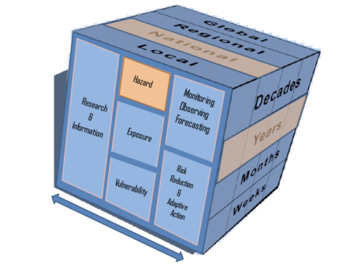Note: We think an interactive version of this cube icon could help highlight the spatial/temporal nature of the risk component being described for reports and other purposes. Even as a navigation feature on the web platform.